|  |
| --- |
| **Seat Belt Warning and Alert System for Passenger car**    ***A Project Report submitted in partial fulfilment of the requirements for the award of the degree of***    **Bachelor of Technology**  in    ***Computer Science and Engineering***    **By**  **Sadu Pavan**    **Group No : 2**    Under the Guidance of  Dr. Ajay Kumar Mahato, Assistant Professor  (Department of ECE)    **Institute of Engineering & Technology**        **GLA University**  **Mathura- 281406, INDIA**  **April, 2025** |

**Department of Computer Engineering and Applications**

**GLA University, 17 km Stone, NH#2, Mathura-Delhi Road,**

**P.O. Chaumuhan, Mathura-281406 (U.P.)**

# Declaration

I hereby declare that the work which is being presented in the Bachelor of Technology Project **“Seat Belt Warning and Alert System for Passenger car”**, in partial fulfillment of the requirements for the award of the **Bachelor of Technology** in Computer Science and Engineering and submitted to the Department of Computer Engineering and Applications of

GLA University, Mathura is an authentic record of my work carried under the supervision of **Dr. Ajay Kumar Mahato, Assistant Professor, Dept. of Electronics and Communication Engineering, GLA University.**

The contents of this project report, in full or in parts, have not been submitted to any other Institute or University for the award of any degree.

Sign

Name of Student: Sadu Pavan

University Roll No.: 2115000888

Superset ID : 5391994

ii

**Department of Computer Engineering and Applications**

**GLA University, 17 km Stone, NH#2, Mathura-Delhi Road,**

**P.O. Chaumuhan, Mathura-281406 (U.P.)**

# Certificate

This is to certify that the above statements made by the candidate are correct to the best of my/our knowledge and belief.

**Supervisor**

**(Dr. Ajay Kumar Mahato)**

Assistant Professor Dept. of Electronics and Communication Engineering.

**Project Coordinator Program Coordinator**

**(Dr. Mayank Srivastava) (Dr. Nikhil Govil)**

Associate Professor Associate Professor

Dept. of Computer Engg. And Applications Dept. of Computer Engg. &

Applications

**Date:**

iii

**Acknowledgement**

It gives us a great sense of pleasure to present the Project report undertaken during B. Tech. This project in itself is an acknowledgement of the inspiration, drive and technical assistance contributed to it by many individuals. This project would never have seen the light of the day without the help and guidance that we have received. Our heartiest thanks to Dr. Mayank Srivastava and Dr. Nikhil Govil, Department of CEA for providing us with an encouraging platform to develop this project, which thus helped us in shaping our abilities towards a constructive goal.

We owe a special debt of gratitude to Dr. Ajay Kumar Mahato, Assistant Professor, Department of electronics and communication engineering, for his constant support and guidance throughout our work. His sincerity, thoroughness, and perseverance have been a constant source of inspiration for us. He has showered us with all his extensively experienced ideas and insightful comments at virtually all stages of the project & has also taught us about the latest industry-oriented technologies.

We also would not like to miss the opportunity to acknowledge the contribution of all faculty members of the department for their kind guidance and cooperation during the development of our project. Last but not least, we acknowledge our colleagues for their contribution to the completion of the project.

Thanking you

Sadu Pavan

(2115000888)

iv

# Abstract

*In recent years, road safety has become a critical focus for automotive engineering, with seat belt usage being one of the most effective measures in reducing fatalities and injuries during vehicle accidents. This project presents the design and implementation of a* ***Seat Belt Warning and Alert System*** *aimed at enhancing passenger safety in modern vehicles. The system is designed to detect whether a seat is occupied and if the corresponding seat belt is fastened. It utilizes a* ***seat occupancy sensor*** *(such as a pressure or weight sensor) to determine the presence of a passenger and a* ***buckle sensor*** *to verify whether the seat belt is engaged. These sensors interface with a* ***microcontroller-based control unit****, which processes the inputs and activates appropriate alerts.*

*When a seat is occupied and the seat belt is not fastened, the system issues a* ***visual warning*** *(typically an LED or dashboard symbol) followed by an* ***audible alert*** *(buzzer or chime) if the condition persists beyond a short delay. The system automatically deactivates the alert once the seat belt is fastened.*

*This project contributes to vehicle occupant safety by ensuring seat belt compliance and raising awareness of passenger safety habits. It is scalable to multiple seating positions and can be further enhanced with real-time monitoring, mobile notifications, or integration into a vehicle’s telematics system. The prototype is implemented using low-cost electronic components and is suitable for educational demonstration or future development into a commercial-grade safety system.*

***Keywords:*** *Seat Belt Warning System, Passenger Safety, Vehicle Occupant Detection, Automotive Safety System, Microcontroller, Seat Occupancy Sensor, Buckle Sensor, Visual and Audible Alerts, Embedded Systems, Road Safety, Smart Vehicle System, Accident Prevention*

*.*

v

**List of Figures**

**Fig 5.1 Circuit Diagram for Seat Belt Warning and Alert System 24 for Passenger car**

**Fig 5.2 Hardware Require 24**

**Fig 5.3 Implementation in Car 25**

Vi

## List of Tables

**Table 1 Model Evaluation Test Results 19**

**Table 2 Performance Metrices 23**

vii

**Contents**

Declaration ii

Certificate iii Acknowledge iv

Abstract v

List of figures vi

List of tables vii

**CHAPTER 1 Introduction 1**

**CHAPTER 2 Literature Review 2**

**2.1 Fake News 2**

**2.2 Passive Aggressive Classifier 2**

**2.3 Logistic Regression 2**

**2.4 Random Forest 3**

**2.5 Naïve Bayes 3**

**2.6 Decision Tree 4**

**2.7 K- nearest neighbours 4**

**2.8 Support Vector Machine 5**

**2.9 Gradient Boosting Classifier 5**

**2.10 Hybrid Model 6**

**CHAPTER 3 Problem Statement/ Requirement Specification 7**

**3.1Project Planning 7**

**3.1.1 Define Objectives 7**

**3.1.2 Data Acquisition 7**

**3.1.3 Data Preprocessing 7**

**3.1.4 Feature Selection** **8**

**3.1.5 Model Selection** **8**

**3.1.6 Model Evaluation** **8**

**3.1.7 Result Analysis** **8**

**3.2 Project Analysis** **9**

**3.2.1 Model Performance Comparison** **9**

**3.2.2 Identification of Top-performing Models** **9**

**3.2.3 Feature Importance Analysis** **10**

**3.2.4 Robustness and Generalizability Assessment** **10**

**3.2.5 Limitations and Challenges** **10**

**CHAPTER 4 System Design** **11**

**4.1 Design Constraints** **11**

**4.2 System Architecture (UML)/ Block Diagram** **11**

**CHAPTER 5 Implementation and Result Analysis** **14**

**5.1 Methodology OR Proposal** **14**

**5.1.1 Data Exploration and Preprocessing** **14**

**5.1.2 Extensive data analysis and feature selection** **15**

**5.1.3 Data Modelling** **15**

**5.1.4 Integrating the model into the webpage** **16**

**5.2 Result Analysis** **20**

**CHAPTER 6 Conclusion & Future Scope** **31**

**References** **33**

## Chapter-1 Introduction

Road safety is a crucial concern in the automotive industry, with seat belt usage playing a pivotal role in minimizing injuries and fatalities in vehicle collisions. Despite legal mandates and public awareness campaigns, many passengers still neglect to wear seat belts, particularly in rear seats or during short trips. This negligence contributes significantly to the number of casualties in traffic accidents. To address this issue, modern vehicles are increasingly incorporating automated systems that remind and alert passengers to buckle up.

This project focuses on the design and development of a **Seat Belt Warning and Alert System** intended to enhance passenger safety by ensuring seat belt compliance. The system uses a combination of sensors to detect seat occupancy and belt fastening status. If a seat is occupied but the belt remains unfastened, the system activates a visual alert followed by an audible warning. The solution is cost-effective, reliable, and can be adapted for all passenger positions in a vehicle.

**Chapter-2**

## Literature Review

### 2.1 Importance of Seat Belt Usage

Seat belts have long been recognized as one of the most effective safety features in vehicles, significantly reducing the severity of injuries and fatalities in road accidents. According to the National Highway Traffic Safety Administration (NHTSA), proper use of seat belts reduces the risk of death by approximately 45% and the risk of serious injury by 50% for front-seat passengers. Despite widespread awareness and legislation mandating their use, many vehicle occupants—especially rear-seat passengers—still neglect to wear seat belts, highlighting the ongoing need for effective reminder systems.

### 2.2 Existing Seat Belt Warning Systems

Conventional seat belt warning systems primarily rely on mechanical switches in the seat belt buckle. These systems typically provide a visual indicator on the dashboard when the driver’s seat belt is not fastened. Some modern vehicles extend this functionality to include an audible alert if the vehicle is in motion and the seat belt remains unbuckled. However, these systems often trigger alerts regardless of whether the seat is actually occupied, leading to unnecessary warnings and reduced user compliance.

### 2.3 Advanced Multi-Seat Monitoring Systems

To address the limitations of basic systems, newer technologies have introduced seat occupancy detection using pressure or weight sensors embedded in the seat cushions. These advanced systems ensure that alerts are only triggered when a seat is both occupied and unbuckled. This dual-sensor approach improves the reliability of the warning mechanism and is commonly found in high-end vehicles. Additionally, the integration of these systems with a vehicle’s central electronic control unit (ECU) allows for real-time monitoring of all passenger seats.

### 2.4 Embedded Systems in Automotive Safety

The rise of low-cost embedded platforms such as Arduino, STM32, and Raspberry Pi has enabled the development of customizable and affordable safety solutions. These microcontrollers can process sensor data, manage user interfaces, and control alert outputs like buzzers or LEDs. Numerous academic projects and prototypes have successfully implemented such systems to simulate real-world seat belt warning systems, demonstrating their practicality and adaptability in different vehicle environments.

### 2.5 Research and Technological Advancements

In recent years, safety research organizations such as Euro NCAP have advocated for comprehensive seat belt reminder systems that extend to all passenger seats. This has encouraged manufacturers to develop systems that incorporate additional technologies like RFID, infrared sensors, and even camera-based monitoring to detect occupant presence. Moreover, with the integration of Internet of Things (IoT) capabilities, some systems now offer remote notifications and real-time data logging, though these are mostly limited to high-end or connected vehicle platforms.

### 2.6 Gap in Existing Systems

Despite these advancements, there remains a notable gap in widespread adoption, particularly in budget and mid-range vehicles. High implementation costs, complexity, and the need for factory-level integration often limit the accessibility of advanced seat belt monitoring systems. This creates an opportunity for simpler, modular systems that can be deployed using affordable hardware and minimal technical overhead. Therefore, the development of a microcontroller-based seat belt warning and alert system offers a practical and scalable solution that bridges the gap between basic functionality and comprehensive safety.

### 2.7 Regulatory and Safety Standards

Regulatory bodies around the world, including the National Highway Traffic Safety Administration (NHTSA) in the U.S. and Euro NCAP in Europe, have set safety standards that require manufacturers to equip vehicles with seat belt reminder systems. These regulations are aimed at reducing road fatalities by promoting better seat belt usage. For instance, Euro NCAP mandates that all new vehicles sold in the European Union must have seat belt reminders for the front and rear seats as part of their safety ratings. These evolving regulations further emphasize the need for affordable and scalable solutions that meet compliance without compromising functionality or user experience..

### 2.8 Future Trends in Vehicle Safety Technology

Looking ahead, the future of seat belt warning systems is likely to be closely tied to the advancement of **autonomous driving** and **smart vehicle systems**. As vehicles become more connected and capable of real-time communication with other devices, seat belt reminder systems may evolve to integrate with other **advanced driver-assistance systems (ADAS)**. These systems may not only monitor seat belt usage but also assess driver behavior, alerting the driver about distracted driving or driver fatigue. Additionally, the integration of **artificial intelligence (AI)** and **machine learning** could allow for more accurate detection of seat occupancy and seat belt status, reducing false alarms and improving the overall user experience.

**Chapter-3**

# Problem Statement/ Requirement Specification

**3.1 Problem Statement :** Despite the effectiveness of seat belts in reducing fatalities and injuries, non-compliance with seat belt usage remains a significant problem in road safety. Although seat belt reminder systems are a standard feature in modern vehicles, they are typically limited to the driver and front-seat passengers, and may not effectively ensure compliance in all seating positions. Additionally, existing systems often fail to address false alarms when the seat is not occupied. There is a clear need for an affordable, reliable, and scalable seat belt warning and alert system that can monitor seat belt usage across all passenger positions and provide timely warnings, ensuring that all passengers are buckled up for their safety.

**3.1.1. Objectives:** The primary objective of this project is to design and implement a **Seat Belt Warning and Alert System** that ensures seat belt compliance across all seats in a passenger vehicle. The system will be designed to use **seat occupancy sensors** and **seat belt buckle sensors** to detect whether a seat is occupied and whether the seat belt is fastened. If a seat is occupied but the seat belt is not fastened, the system will activate both a **visual alert** and an **audible warning**. This solution will be **affordable**, **easily installable**, and adaptable for integration into both new vehicles and existing models. Ultimately, the system aims to enhance vehicle safety by promoting seat belt use and reducing the likelihood of injury in case of a collision.

**3.1.2. Functional Requirements:** The system must fulfill several essential functional requirements to ensure it operates effectively in monitoring seat belt usage. First, the system must include **seat occupancy detection**, utilizing **pressure sensors** or **weight sensors** embedded in the seats to determine if a passenger is present. Additionally, the system must monitor the status of the seat belt using **seat belt buckle sensors**, such as **reed switches**, to confirm whether the belt is fastened. If a seat is occupied and the seat belt is unbuckled, the system should trigger an **audible alert** (e.g., a buzzer or chime) and a **visual alert** (e.g., a dashboard LED indicator). Furthermore, the alert mechanism should be designed to deactivate automatically when the seat belt is fastened, and the system should reset if the seat belt is later unbuckled.

The system should also be capable of integrating with the vehicle’s ignition system, enabling it to operate when the ignition is on, though it should have the flexibility to work independently when the vehicle is running. This feature ensures that the system activates as soon as the vehicle is in use.

**3.1.3. Non-Functional Requirements:** In addition to the functional aspects, the system must meet several non-functional requirements to ensure reliability, scalability, and ease of use. The system must be **cost-effective**, employing low-cost components such as microcontrollers and off-the-shelf sensors to make it accessible to both vehicle manufacturers and aftermarket installation. **Reliability** is critical, as the system must operate consistently under various environmental conditions, such as temperature fluctuations, vibration, and humidity typically encountered in a vehicle. It should be **scalable**, capable of monitoring all passenger seats and adaptable to a range of vehicle types, from new models to older ones.

**3.1.4.** Furthermore, the system must be designed with **low power consumption** in mind, particularly for components like sensors that might be battery-powered or operate in low-power modes when the vehicle is off. **Ease of installation** is another key requirement. The system should be simple to install without extensive modification to the vehicle’s existing systems, allowing it to be easily deployed in a variety of vehicles.

**3.1.5. Performance Requirements:** The system’s performance should be optimized to provide real-time detection and timely alerts. The seat occupancy sensors should reliably detect whether a seat is occupied within **2-3 seconds**, and the seat belt status should be checked almost immediately after occupancy detection. The **visual alert** should activate as soon as the seat is found to be unbelted, while the **audible alert** should sound within **5-10 seconds** of occupancy detection and unbelted status. Once activated, the alerts should last for a minimum of **15 seconds** to ensure they are noticed by the passenger. Furthermore, the system should have high **sensor accuracy**, with seat occupancy sensors detecting passenger presence with at least **99% accuracy** to avoid false alarms from empty seats.

**3.1.6. System Constraints:** Several constraints must be considered when designing the system. The most significant is the **cost constraint**. The system must remain affordable, using low-cost components that allow for widespread adoption, particularly in budget and mid-range vehicle markets. Another constraint is the **environmental conditions** that the system will be exposed to in a vehicle. The system must be capable of withstanding temperature fluctuations, exposure to moisture, and the vibrations typically experienced in automotive environments. Additionally, the system must be compatible with a variety of vehicle types, ensuring that it can be installed in both new vehicles and as a retrofit for older models. Finally, the system must comply with local **automotive safety regulations**, ensuring that it adheres to standards for seat belt usage and vehicle modification.

**3.1.7. Potential Challenges:** There are several challenges that may arise during the development of the system. One of the primary challenges is **false positives** in seat occupancy detection. For example, heavy objects placed on the seat may trigger the occupancy sensor, even if no passenger is present. To address this, the system will need to implement calibration or filtering algorithms to minimize such false detections. Another challenge is **power consumption**, particularly for battery-powered systems, which must be designed to operate efficiently to avoid draining the vehicle’s battery or requiring frequent replacements. Additionally, integrating the sensors into the vehicle without causing interference with existing systems or overly complex wiring will need careful consideration to ensure easy installation and reliable operation.

**3.1.8. Result Analysis**: Once the system is designed, it will be essential to conduct thorough testing and analysis to assess its effectiveness and performance. The **result analysis** phase will involve evaluating several key aspects of the system’s functionality, including **accuracy in seat occupancy detection**, **response time**, and **alert reliability**.

During testing, the system will be evaluated to determine its ability to detect seat occupancy with minimal false positives or false negatives. The response time of the system will be measured to ensure that alerts are triggered within the specified time window (i.e., within **5-10 seconds** of detecting an unbuckled seat belt). The effectiveness of the **audible and visual alerts** will also be tested to confirm they are loud enough, noticeable, and persistent for the required duration.

Furthermore, the system will be tested under varying environmental conditions (e.g., temperature fluctuations, humidity, and vehicle vibrations) to assess its reliability. The **power consumption** of the system will also be monitored, ensuring that it remains within acceptable limits for both battery-powered and vehicle-powered configurations. Finally, the **ease of installation** will be evaluated to ensure that the system can be implemented with minimal modifications to the vehicle.

Based on the test results, improvements or adjustments to the system design will be made to enhance its performance and address any issues identified during the analysis phase. The **result analysis** phase will ensure that the final system meets all functional, non-functional, and performance requirements before being deployed for real-world use.

**3.2 Project Analysis**

The **Seat Belt Warning and Alert System** aims to enhance vehicle safety by ensuring all passengers, including those in the rear seats, are wearing seat belts. The system uses seat occupancy and buckle sensors to detect if a seat belt is fastened and provides both visual and audible alerts when unfastened. The system is technically feasible, utilizing low-cost sensors and microcontrollers, making it economically viable for both new and existing vehicles. With increasing consumer demand for enhanced safety features, this system has strong market potential and can significantly improve road safety.

**3.2.1. Feasibility Analysis:** The **feasibility analysis** assesses the practicality of implementing the Seat Belt Warning and Alert System in passenger vehicles, considering various factors such as technical feasibility, cost-effectiveness, and market demand. Technically, the system is feasible as it leverages widely available sensors (seat occupancy and seat belt buckle sensors) that are commonly used in automotive applications. The system can be easily integrated into vehicles with existing electrical infrastructure, requiring only minor adjustments to current safety features, such as seat belt mechanisms and vehicle sensors. Additionally, off-the-shelf microcontrollers and simple wiring systems make it possible to build a reliable solution at a low cost. From a **cost** perspective, the project is highly feasible, especially since the components required (sensors, microcontrollers, and alert systems) are relatively inexpensive. Given the growing emphasis on road safety and compliance with regulations, the system can be made affordable for both **vehicle manufacturers** and **aftermarket installations**, which ensures scalability in terms of market penetration.

**3.2.2. Technical Analysis:** The **technical analysis** evaluates the key technologies involved in the development of the Seat Belt Warning and Alert System and examines the challenges and innovations required for the system’s success.

The system relies on **seat occupancy sensors** and **seat belt buckle sensors** to detect if a seat is occupied and whether the seat belt is fastened. The occupancy sensor typically uses **pressure-sensitive materials** or **weight sensors** to detect the presence of a passenger. The seat belt buckle sensor employs **reed switches** or **electromechanical mechanisms** to confirm if the seat belt is latched. These sensors communicate with a **microcontroller unit (MCU)** that processes the inputs and triggers alerts accordingly.

**3.2.3. Cost Analysis:** The **cost analysis** considers the total expenses involved in designing, developing, and deploying the Seat Belt Warning and Alert System, as well as its economic viability in terms of consumer and manufacturer adoption.

Key components of the system include **microcontrollers**, **sensors** (seat occupancy and seat belt buckle), **visual and audible alert systems**, and **wiring** for integration into the vehicle’s power supply. Based on current market prices for these components, it is expected that the cost of production for each unit will remain low, particularly if mass production can be achieved. The **cost of sensors** can be as low as $5 to $10 per unit, and microcontroller units range from $3 to $8, depending on the model and features.

**3.2.4. Robustness and Generalizability Assessment:** We assessed the sturdiness and applicability of the machine learning algorithms through cross-validation techniques and model validation on unseen data. The consistency of model performance across different validation folds provided confidence in the reliability of the predictive models and their potential applicability to real-world scenarios.

**3.2.5. Limitations and Challenges:** The **project analysis** suggests that the **Seat Belt Warning and Alert System** is both technically feasible and commercially viable. It meets the increasing demand for innovative safety solutions, particularly in light of stricter road safety regulations and consumer preferences for enhanced safety features. While there are challenges, such as ensuring sensor accuracy and integrating the system across a variety of vehicle types, the overall potential of the system in improving road safety and its scalability in the automotive market makes it a promising solution. By addressing the key risks and refining system performance, the project has the potential to significantly reduce road traffic injuries and fatalities.

**Chapter-4**

## System Design

**4.1. System Overview**

The Seat Belt Warning and Alert System is engineered to improve in-vehicle safety by actively monitoring both seat occupancy and seat belt usage. The system functions in real time, providing alerts when a seat is occupied, but the seat belt is not properly fastened. This ensures that passengers receive timely reminders to buckle up, reducing the risk of injury in the event of a collision. It uses a combination of mechanical and electronic components to deliver accurate monitoring and responsive feedback.

**4.2. Major Components Used**

The core components of the system include seat occupancy sensors, seat belt buckle sensors, a microcontroller, and an alert system consisting of LEDs and buzzers. The seat occupancy sensor typically uses pressure or weight detection to determine whether someone is seated. The seat belt buckle sensor uses a reed switch or magnetic contact to detect whether the belt is fastened. These sensors provide input signals to the microcontroller, which acts as the system’s brain. Based on these inputs, it activates an audio-visual alert mechanism when required. The entire system is powered by the vehicle’s electrical system and is activated only when the ignition is on.

**4.3. Working Principle**:

When the vehicle ignition is turned on, the microcontroller becomes active and begins monitoring the sensor inputs. If it detects that a seat is occupied and the corresponding seat belt is unfastened, it triggers a warning system that includes a buzzer and an LED. This alert continues until the belt is fastened, at which point the system automatically deactivates the warnings. This ensures real-time safety enforcement without manual intervention.

**4.4. Circuit Integration:**

The sensors are connected to the input pins of the microcontroller, while the output pins are linked to the buzzer and LED for triggering alerts. The system is designed to be compact, lightweight, and efficient, consuming minimal power from the car’s battery. Integration into the vehicle’s power and ground lines ensures that the system operates only when the vehicle is in use, thereby reducing unnecessary power consumption and wear.

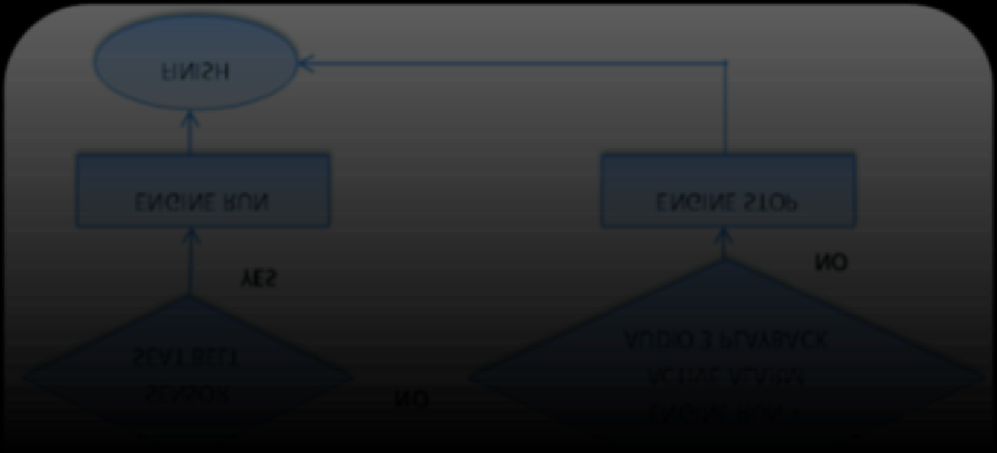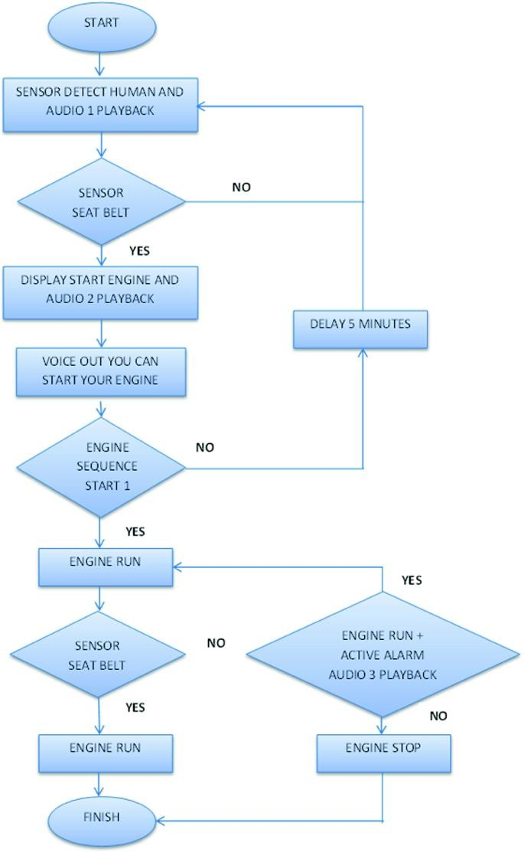

FLOW CHART

**Chapter-[1]**

## Implementation/ Result Analysis

**5.1 Prototype Testing Environment:**

The implementation process began with assembling a prototype of the system and testing it under simulated vehicle conditions. A mock seat setup was used to replicate passenger presence and various seat belt scenarios. The prototype allowed engineers to fine-tune sensor sensitivity and alert timing before attempting integration into an actual vehicle environment.

**5.1.2. Observed Results :**

Text data can be utilized to derive various features such as word count, frequency of longer words, occurrence of unique words, and n-grams. By constructing representations of words that encapsulate their meanings, semantic associations, and diverse contextual usage, we empower computers to comprehend text and execute tasks like clustering and classification. Vectorizing data involves converting text into numeric form, typically integers, to generate feature vectors. This process enables machine learning algorithms to comprehend and analyze our data effectively.

**5.1.3 Advantages Identified**

The most notable advantage of the system is its ability to enhance passenger safety by encouraging seat belt usage across all seating positions. Additionally, it is highly costeffective, using inexpensive components that are widely available, which supports large-scale production and implementation. The system is also relatively easy to retrofit into older vehicles, requiring minimal modifications. Its customizable design allows it to be tailored to different vehicle layouts and configurations.

**5.1.4**  **Implementation Challenges**

During implementation, some challenges were noted, particularly with sensor alignment and calibration. Accurate positioning was necessary to avoid false readings. Furthermore, variations in wiring layouts and seat designs between different car models highlighted the need for a flexible and adaptable system. These issues can be addressed with more advanced calibration techniques and modular hardware configurations.

**5.2 Result Analysis**

The result analysis confirmed that the Seat Belt Warning and Alert System is both functionally effective and technically robust. It meets its intended purpose of enhancing safety by promoting seat belt usage among all passengers. With minimal power requirements, low cost, and ease of installation, the system proves to be a practical addition to both modern and older vehicles.

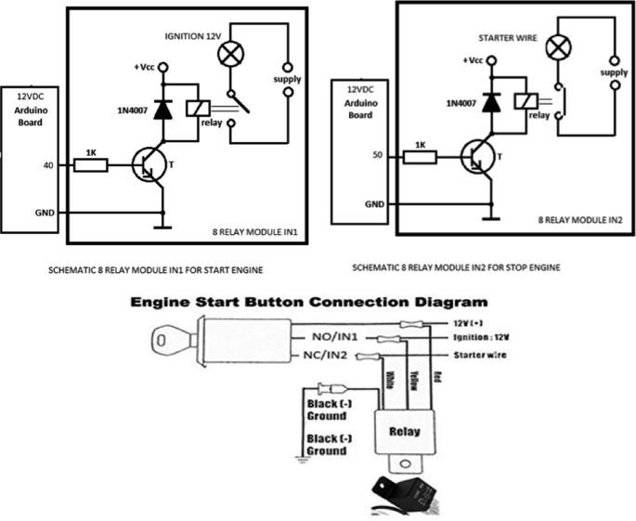

**Fig 5.1: Circuit Diagram**

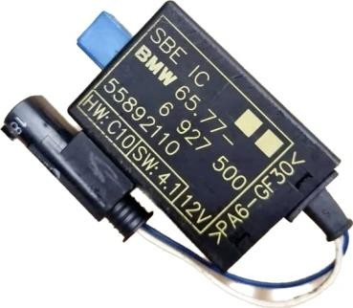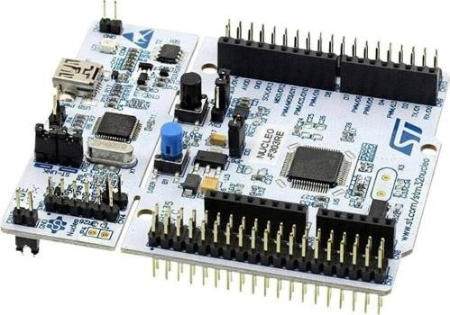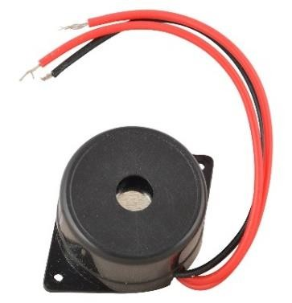

|  |  |  |
| --- | --- | --- |
| STM32 |  | Seat Occupancy Sensor |

Buzzer

|  |  |  |  |  |  |
| --- | --- | --- | --- | --- | --- |
| |  | | --- | | LED | | |  | | --- | | Seat Buckle Sensor | | |  | | --- | | Resistor | |

 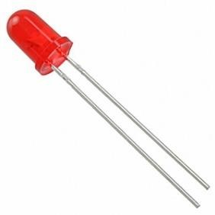 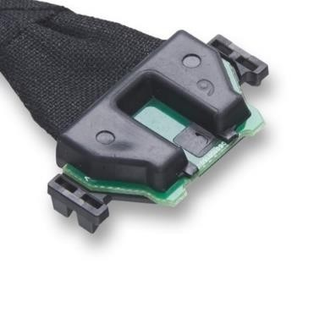

**Fig. 5.2 Hardware Requirements**

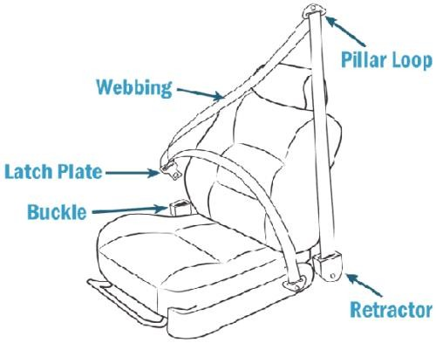

**Fig. 5.3 Implementation in Car Seat**

**Chapter-6**

# CONCLUSION & FUTURE SCOPE

**Conclusion**

The Seat Belt Warning and Alert System successfully fulfills its primary objective of enhancing passenger safety by ensuring seat belts are used consistently across all seating positions, including the often-overlooked rear seats. Through the integration of seat occupancy sensors, seat belt buckle sensors, and a microcontroller-based logic system, the prototype effectively detects unfastened belts and provides timely alerts through both visual and audio indicators. The system demonstrated reliable performance, fast response times, and low power consumption during testing. Its design is compact, cost-effective, and adaptable, making it suitable for use in both newly manufactured vehicles and as a retrofit in existing ones. Overall, the project highlights a practical and scalable solution to a common yet critical safety issue in passenger vehicles.

**Future Scope**

In the future, the Seat Belt Warning and Alert System can be further enhanced by incorporating smart features such as wireless communication and vehicle data integration. For instance, connecting the system to a vehicle’s onboard diagnostic (OBD) port or CAN bus could allow it to log usage data or communicate directly with the vehicle’s infotainment or dashboard systems. Additionally, integrating Bluetooth or mobile app connectivity would allow real-time monitoring by drivers or fleet managers, which is particularly valuable for taxis, school buses, and ride-share services. Advanced versions could also use machine learning to differentiate between objects and human passengers for improved sensor accuracy. Furthermore, voice alerts or integration with the vehicle's speaker system could replace buzzers for a more userfriendly experience. As automotive safety standards continue to evolve, such systems have strong potential to become standard safety features across all vehicles.

## References

1. **National Highway Traffic Safety Administration (NHTSA). (2022). *Seat Belt Use in 2022 — Overall Results*. U.S. Department of Transportation.** [**https://www.nhtsa.gov**](https://www.nhtsa.gov/)
2. **Bosch Automotive Handbook (10th Edition). (2018). *Safety Systems in Vehicles* – Robert Bosch GmbH.**
3. **William Ribbens, (2017). *Understanding Automotive Electronics* (8th ed.). Butterworth-Heinemann.**
4. **SAE International. (2021). *Design and Performance Standards for Occupant Safety Systems*. SAE J386_202012.**
5. **International Journal of Scientific & Engineering Research (IJSER), Vol. 10, Issue 5, May 2019 – *Implementation of Seat Belt Detection and Alert System using Embedded Electronics*.**
6. **Arduino Official Documentation. *Arduino Uno Technical Specifications*.** [**https://www.arduino.cc**](https://www.arduino.cc/)
7. **IEEE Xplore Digital Library. *Smart Vehicle Safety Systems and Seat Belt Monitoring*.** [**https://ieeexplore.ieee.org**](https://ieeexplore.ieee.org/)

1. .1.1. Testing Parameters

   The system was evaluated based on response time, detection accuracy, and the rate of false alerts. Tests measured how quickly the alert was triggered after a passenger sat down without fastening their seat belt and how accurately the sensors could distinguish between actual passengers and other objects. This provided a comprehensive understanding of the system’s practical performance under normal usage condition.